# 

MongoDB is a popular NOSQL database. Perform basic CRUD operations.

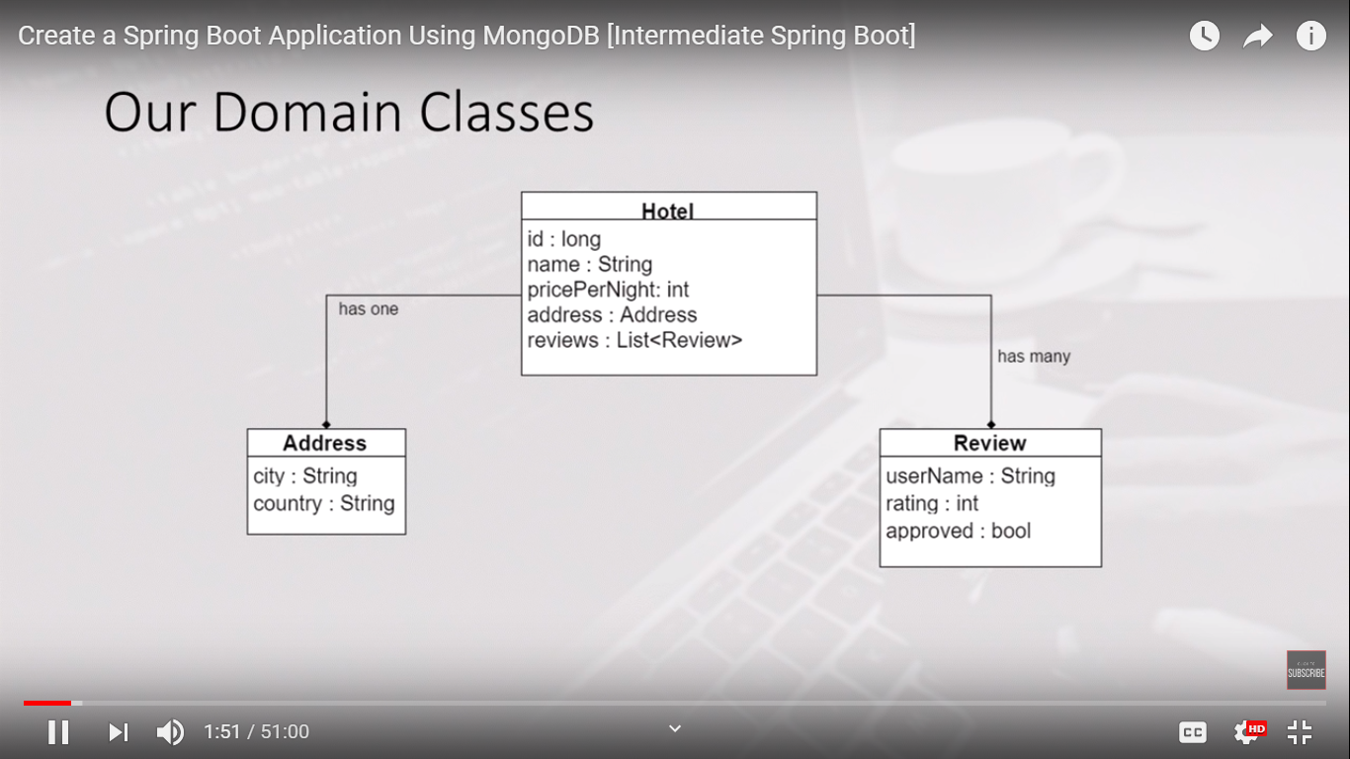

Hotel can have a single address and as well as it can have a list of reviews(multiple reviews).

There are 3 classes Hotel, Address and Review. The 3 classes Hotel, Address and Review form the aggregate, and the root is the Hotel entity.

In MongoDB a single document will grab all the 3 classes.

Hotel.java

Only with parameterised public constructor and only getters

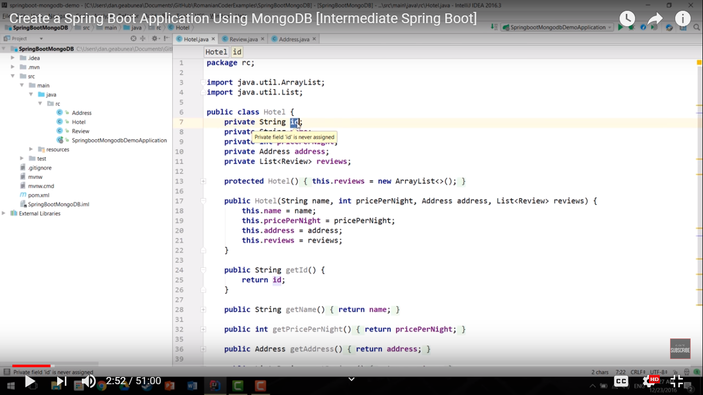

package com.soumyadeep.microservices.model;

import java.util.List;

import org.springframework.data.annotation.Id;

import org.springframework.data.mongodb.core.index.IndexDirection;

import org.springframework.data.mongodb.core.index.Indexed;

import org.springframework.data.mongodb.core.mapping.Document;

@Document(collection="Hotels")

public class Hotel {

@Id

private String id;

private String name;

@Indexed(direction=IndexDirection.ASCENDING)

private int pricePerNight;

private Address address;

private List<Review> reviews;

protected Hotel() {}

public Hotel(String id, String name, int pricePerNight, Address address, List<Review> reviews) {

super();

this.id = id;

this.name = name;

this.pricePerNight = pricePerNight;

this.address = address;

this.reviews = reviews;

}

public String getId() {

return id;

}

public String getName() {

return name;

}

public int getPricePerNight() {

return pricePerNight;

}

public Address getAddress() {

return address;

}

public List<Review> getReviews() {

return reviews;

}

@Override

public String toString() {

return "Hotel [id=" + id + ", name=" + name + ", pricePerNight=" + pricePerNight + ", address=" + address

+ ", reviews=" + reviews + "]";

}

}

Review.java

Only with parameterised public constructor and only getters

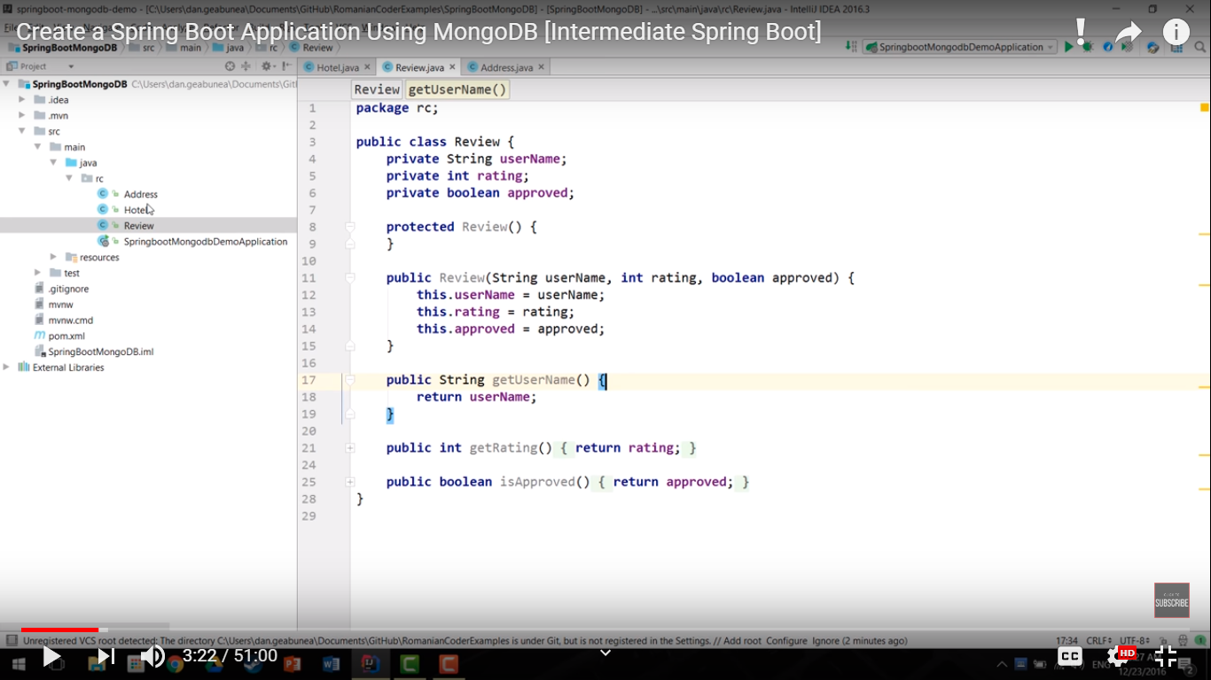

**package** com.soumyadeep.microservices.model;

**public** **class** Review {

**private** String userName;

**private** **int** rating;

**private** **boolean** approved;

**protected** Review() {}

**public** Review(String userName, **int** rating, **boolean** approved) {

**super**();

**this**.userName = userName;

**this**.rating = rating;

**this**.approved = approved;

}

**public** String getUserName() {

**return** userName;

}

**public** **int** getRating() {

**return** rating;

}

**public** **boolean** isApproved() {

**return** approved;

}

@Override

**public** String toString() {

**return** "Review [userName=" + userName + ", rating=" + rating + ", approved=" + approved + "]";

}

}

Address.java

Only with parameterised public constructor and only getters

**package** com.soumyadeep.microservices.model;

**public** **class** Address {

**private** String city;

**private** String country;

**protected** Address() {}

**public** Address(String city, String country) {

**super**();

**this**.city = city;

**this**.country = country;

}

**public** String getCity() {

**return** city;

}

**public** String getCountry() {

**return** country;

}

@Override

**public** String toString() {

**return** "Address [city=" + city + ", country=" + country + "]";

}

}

Before we move on we need to have MongoDB specific annotations.

Hotel is the aggregate root.

@Document - basically we are telling MongoDB that this object should be treated as a MongoDB document and stored in a collection and optionally we can pass in the Collection name like @Document(collection=”Hotels”)

In MongoDB Id is not an Integer value rather it is a String value

@Id is primary key identifiers

If we want to make some filtering, we can index various properties. It is optional.

@Indexed(direction=IndexDirection.ASCENDING)

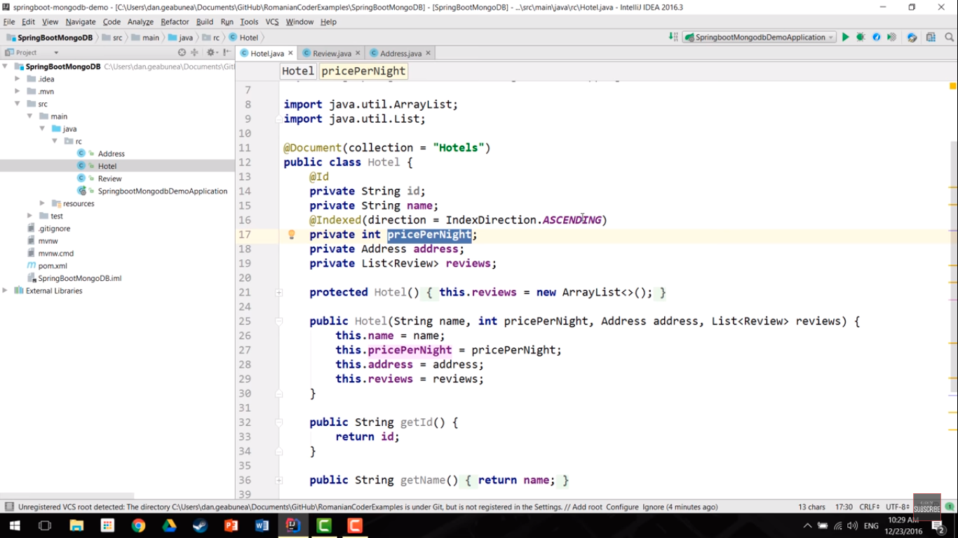

Class extends Class and implements Interface

Interface extends an interface So you can just extend it but not **implement** it. **Implements** denotes defining an **implementation** for the methods of an **interface**. However **interfaces** have no **implementation** so that's not possible. An **interface** can however extend **another interface**, which means it can add more methods and inherit its type.

package com.soumyadeep.microservices.repoisitory;

import org.springframework.data.mongodb.repository.MongoRepository;

import org.springframework.stereotype.Repository;

import com.soumyadeep.microservices.model.Hotel;

@Repository

public interface HotelRepository extends MongoRepository<Hotel,String>{

}

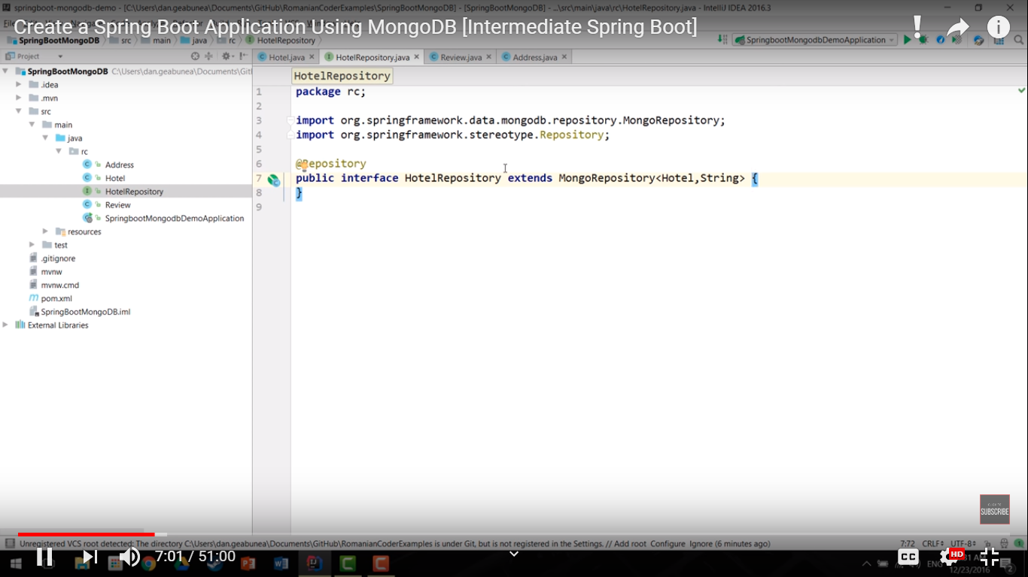

MongoRepository methods are almost similar as JpaRepository

When Spring boot application starts, then CommandLineRunner will be executed automatically by Spring.

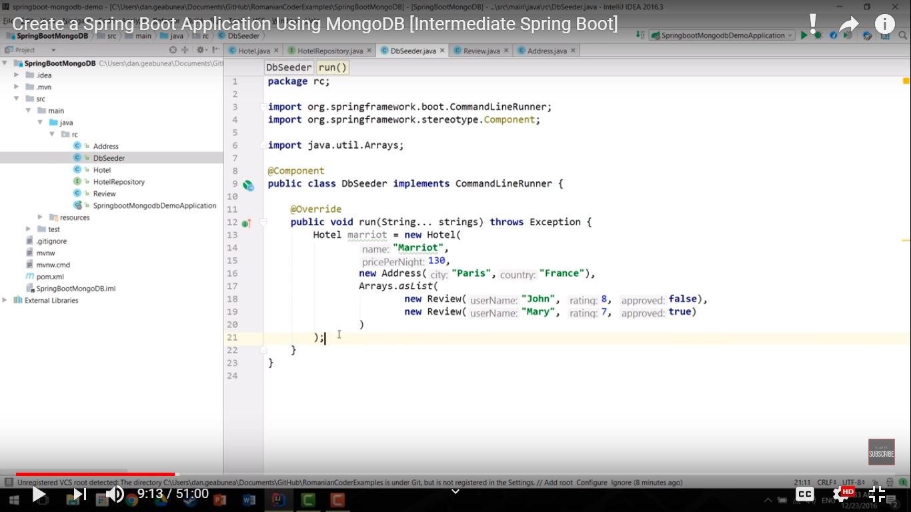

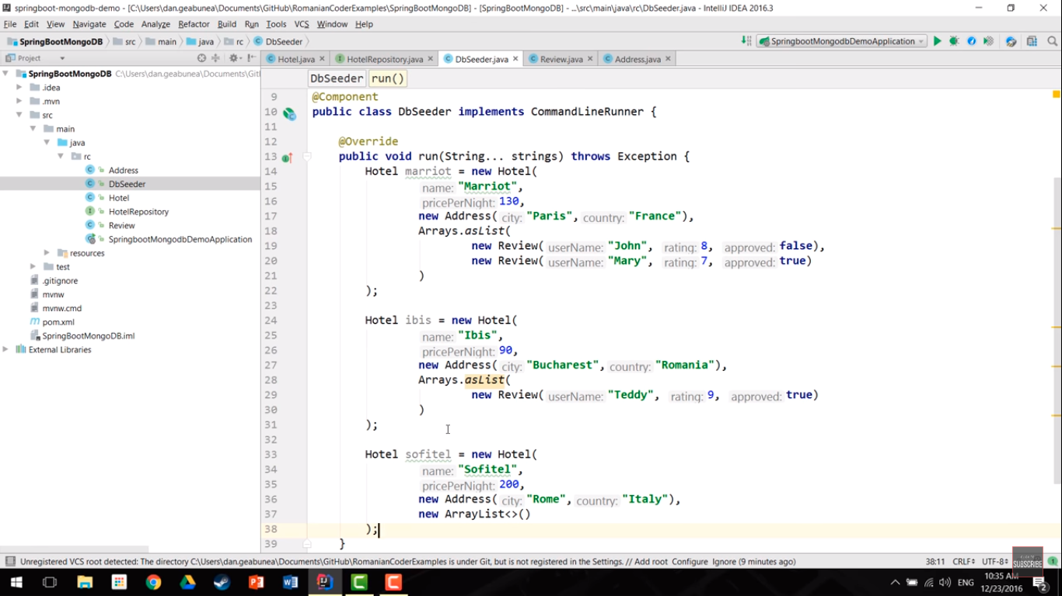

Now we need to save in database each time the application starts

Autowiring the repository

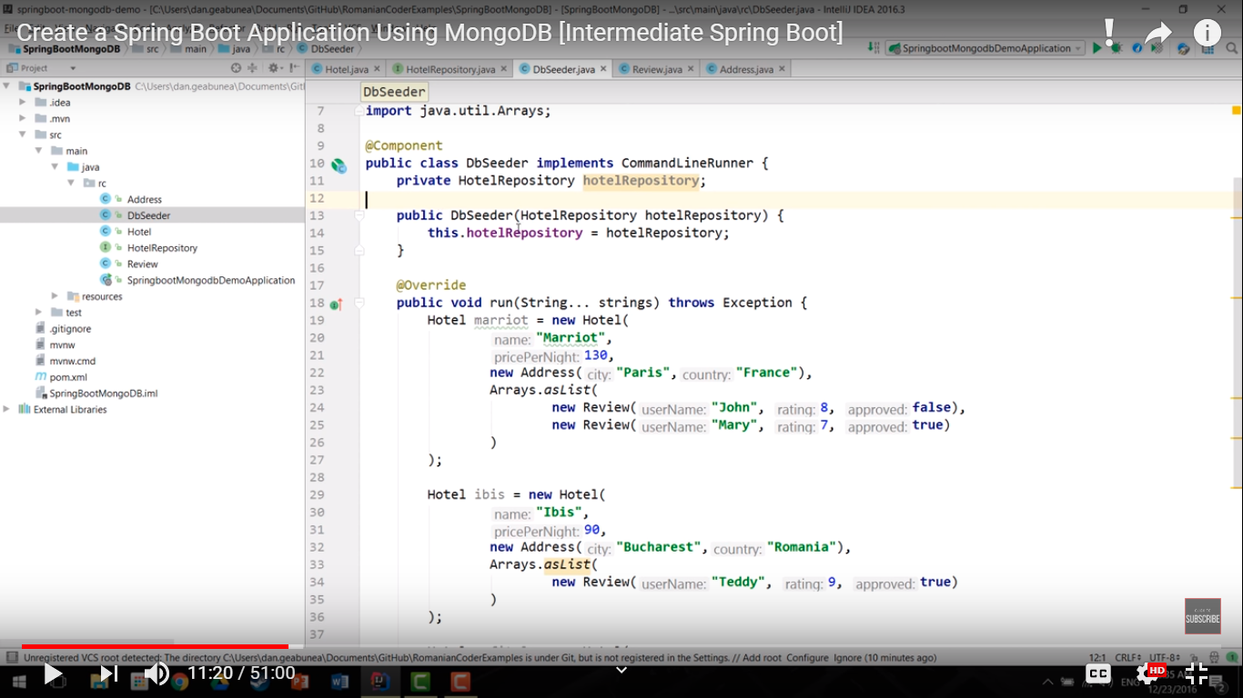

Writing the CRUD functions

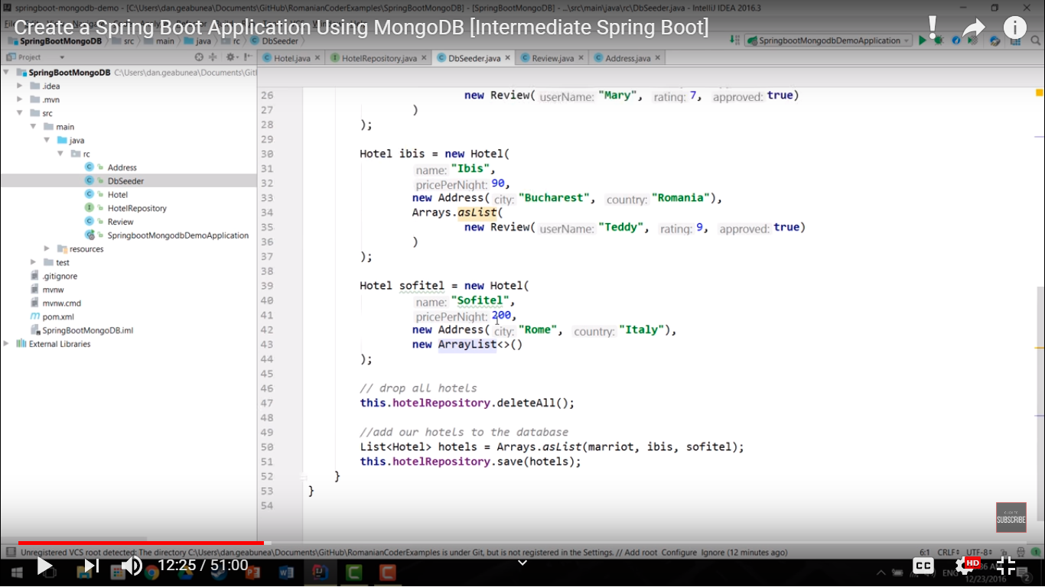

**package** com.soumyadeep.microservices.commandLineRunner;

**import** java.util.Arrays;

**import** java.util.List;

**import** org.springframework.beans.factory.annotation.Autowired;

**import** org.springframework.boot.CommandLineRunner;

**import** org.springframework.stereotype.Component;

**import** com.soumyadeep.microservices.model.Address;

**import** com.soumyadeep.microservices.model.Hotel;

**import** com.soumyadeep.microservices.model.Review;

**import** com.soumyadeep.microservices.repoisitory.HotelRepository;

@Component

**public** **class** DbSeeder **implements** CommandLineRunner{

@Autowired

**private** HotelRepository hotelRepository;

@Override

**public** **void** run(String... Strings) **throws** Exception {

Hotel marriot=**new** Hotel(

"1",

"Marriot",

140,

**new** Address("Paris","France"),

Arrays.*asList*(

**new** Review("a1",8,**true**),

**new** Review("a2",6,**false**)

)

);

Hotel ibis = **new** Hotel(

"2",

"Ibis",

150,

**new** Address("Bucharest","Romania"),

Arrays.*asList*(

**new** Review("a3",4,**false**),

**new** Review("a4",10,**true**)

)

);

Hotel sofitel = **new** Hotel(

"3",

"Sofitel",

160,

**new** Address("Florida","USA"),

Arrays.*asList*(

**new** Review("a5",2,**false**),

**new** Review("a6",12,**true**)

)

);

Hotel demo = **new** Hotel(

"4",

"DemoHotelName",

170,

**new** Address("DemoCity","DemoCountry"),

Arrays.*asList*(

**new** Review("a7",2,**false**),

**new** Review("a8",14,**true**)

)

);

hotelRepository.deleteAll();

List<Hotel> list=Arrays.*asList*(marriot,ibis,sofitel,demo);

hotelRepository.save(list);

}

}

Now create a controller

Making a single parameterized constructor of HotelRepository

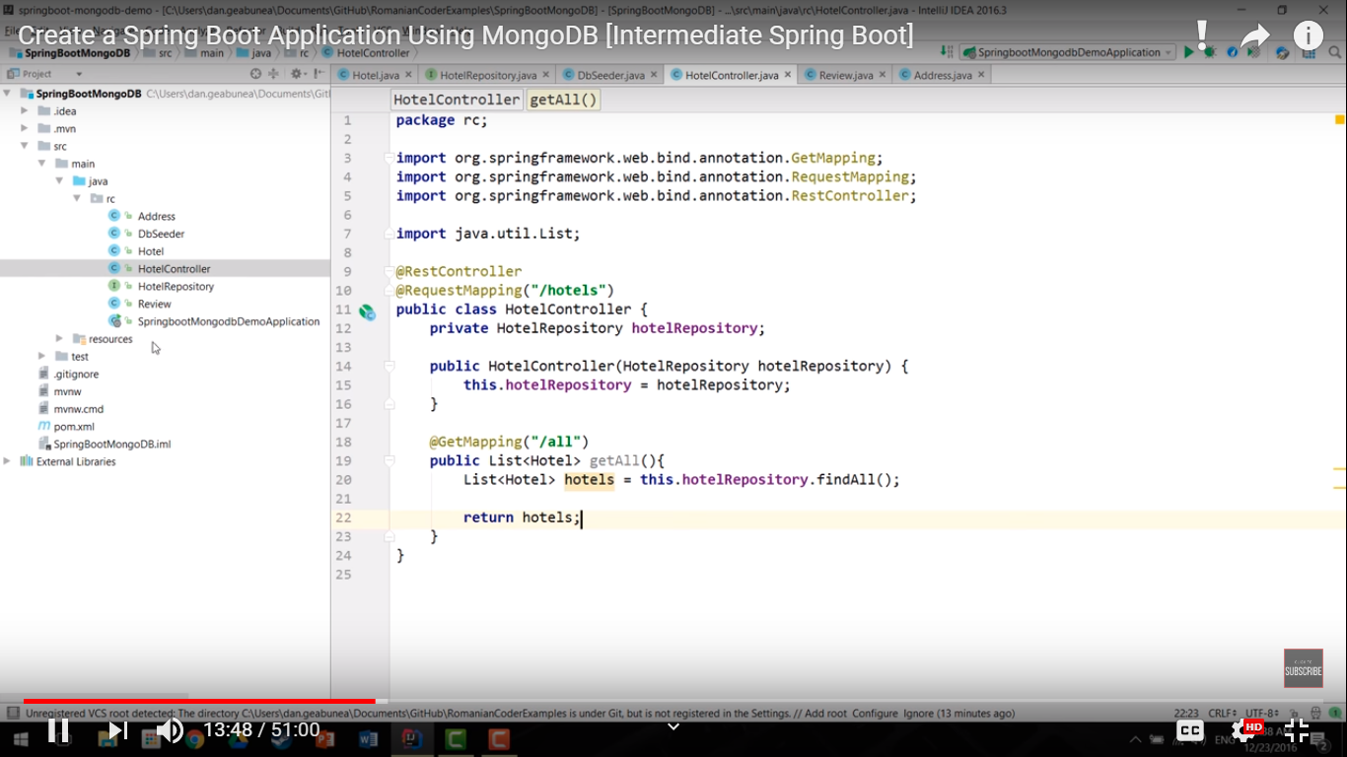

**package** com.soumyadeep.microservices.controller;

**import** java.util.List;

**import** org.springframework.beans.factory.annotation.Autowired;

**import** org.springframework.web.bind.annotation.RequestMapping;

**import** org.springframework.web.bind.annotation.RestController;

**import** com.soumyadeep.microservices.model.Hotel;

**import** com.soumyadeep.microservices.repoisitory.HotelRepository;

@RestController

**public** **class** HotelController {

@Autowired

**private** HotelRepository hotelRepository;

@RequestMapping(value="/all")

**public** List<Hotel> findAll(){

**return** hotelRepository.findAll();

}

}

Create the application properties

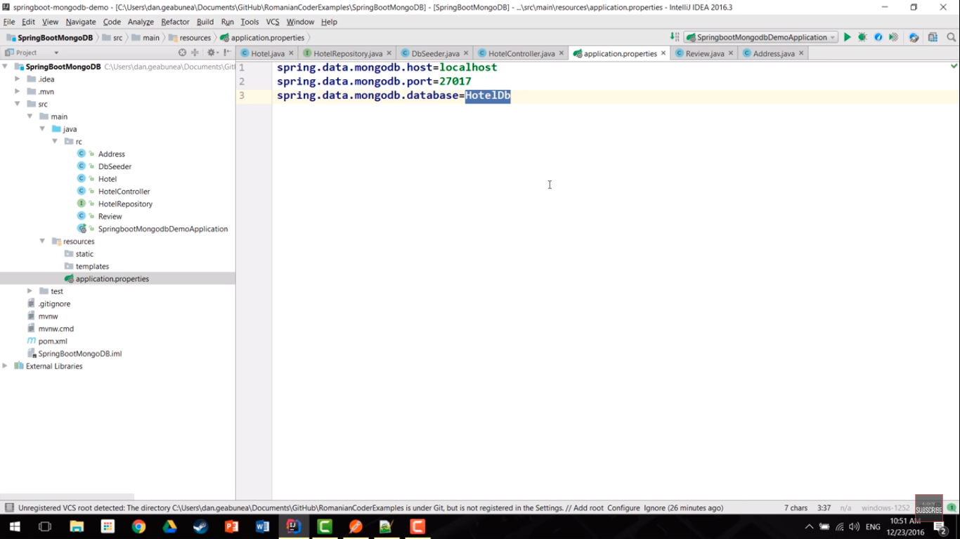

spring.data.mongodb.host=localhost

spring.data.mongodb.port=27017

spring.data.mongodb.database=HotelDb

Like H2, HSQL we can have in-memory database, in MongoDb we cannot have in-memory approach, so in order to make MongoDB work we need to have MongoDB installed.

Robomongo is a GUI for MongoDB.

Run the Application

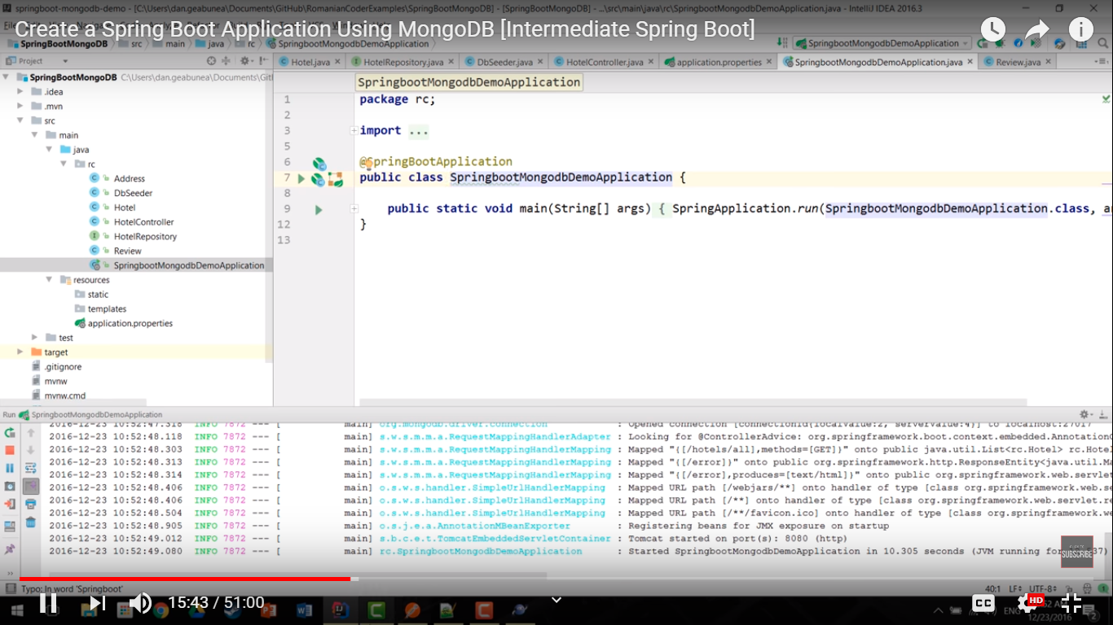

Goto to Robomongo and see that HotelDb

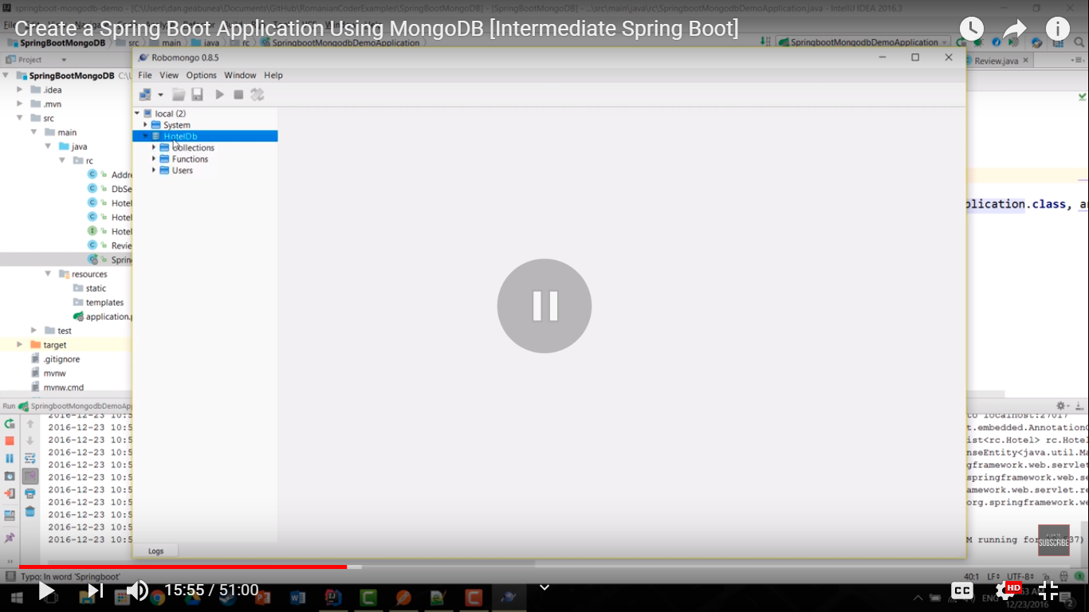

“Hotels” collection in the name as given in model. It has 3 objects.

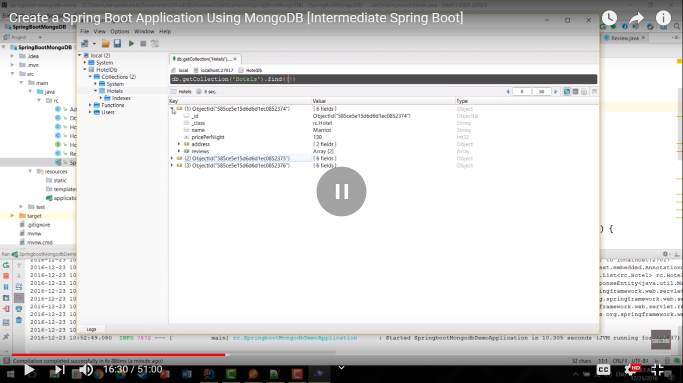

Hit the controller methods

All

localhost:8080/all

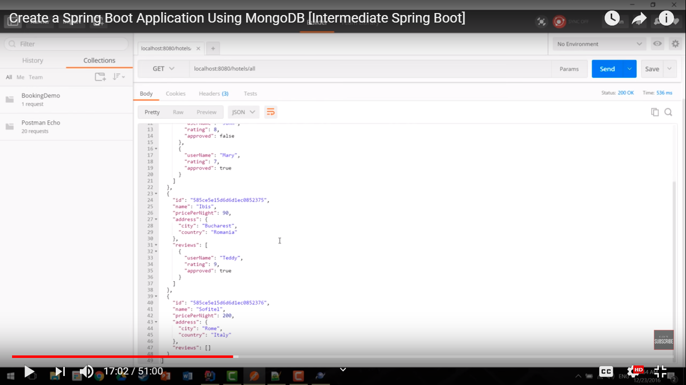

Difference between insert() and save() method

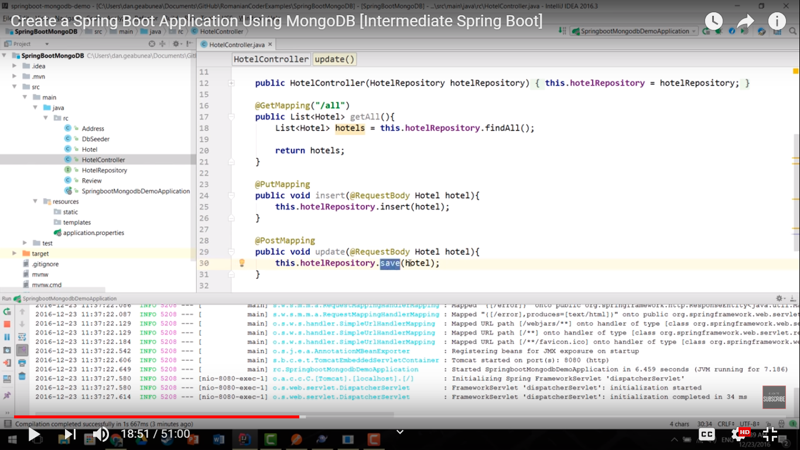

save() works as an insert and update.

insert() just inserts data.

To insert the document you can use **db.post.save(document)** also. If you don't specify **_id** in the document then **save()** method will work same as **insert()** method. If you specify _id then it will replace whole data of document containing _id as specified in save() method.

Delete method

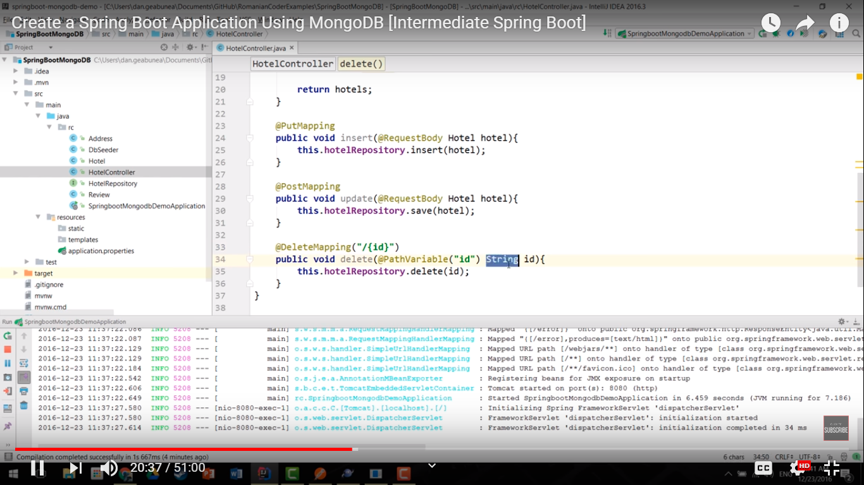

**package** com.soumyadeep.microservices.controller;

**import** java.util.List;

**import** org.springframework.beans.factory.annotation.Autowired;

**import** org.springframework.web.bind.annotation.PathVariable;

**import** org.springframework.web.bind.annotation.RequestBody;

**import** org.springframework.web.bind.annotation.RequestMapping;

**import** org.springframework.web.bind.annotation.RequestMethod;

**import** org.springframework.web.bind.annotation.RestController;

**import** com.soumyadeep.microservices.model.Hotel;

**import** com.soumyadeep.microservices.repoisitory.HotelRepository;

@RestController

**public** **class** HotelController {

@Autowired

**private** HotelRepository hotelRepository;

@RequestMapping(value="/all")

**public** List<Hotel> findAll(){

**return** hotelRepository.findAll();

}

@RequestMapping(value="/insert", method=RequestMethod.***POST***)

**public** **void** insert(@RequestBody Hotel hotel){

hotelRepository.save(hotel);

}

@RequestMapping(value="/update", method=RequestMethod.***PUT***)

**public** **void** update(@RequestBody Hotel hotel){

hotelRepository.save(hotel);

}

@RequestMapping(value="/{id}", method=RequestMethod.***DELETE***)

**public** **void** delete(@PathVariable(name="id") String id){

hotelRepository.delete(id);

}

}

Start the application

Extract all the Hotels

localhost:8080/all

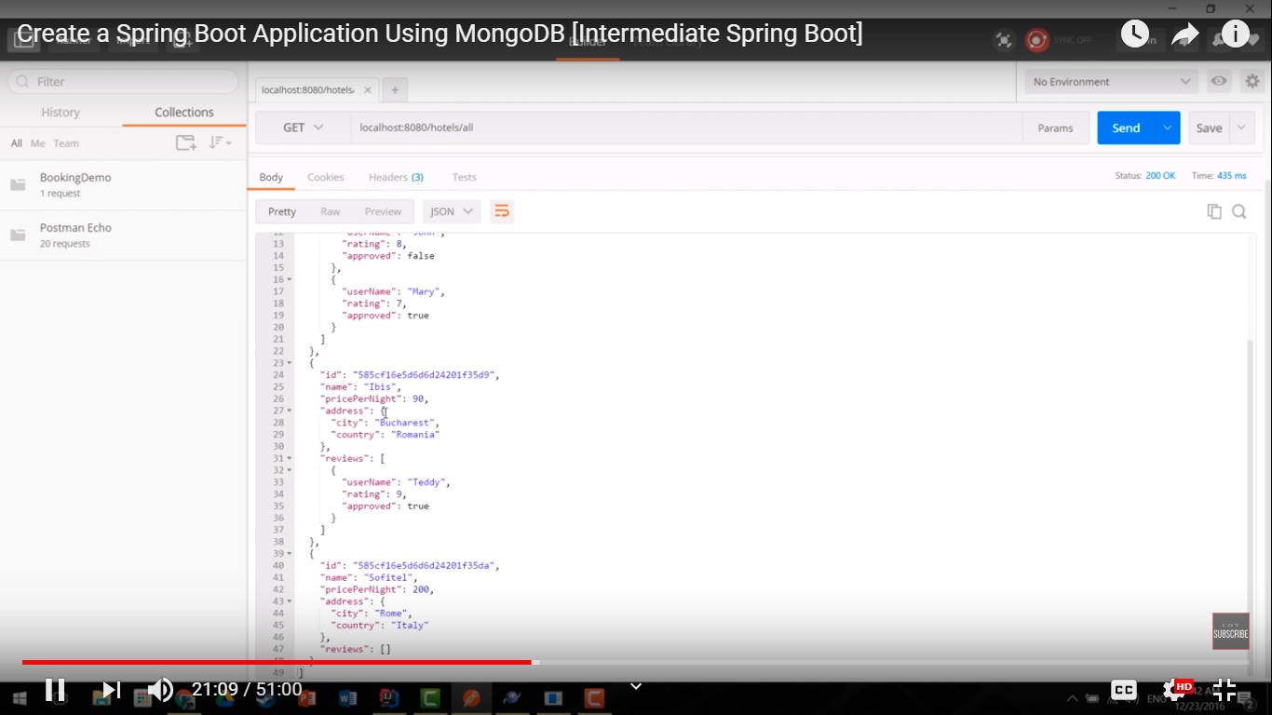

Delete Sofitel with id

localhost:8080/3

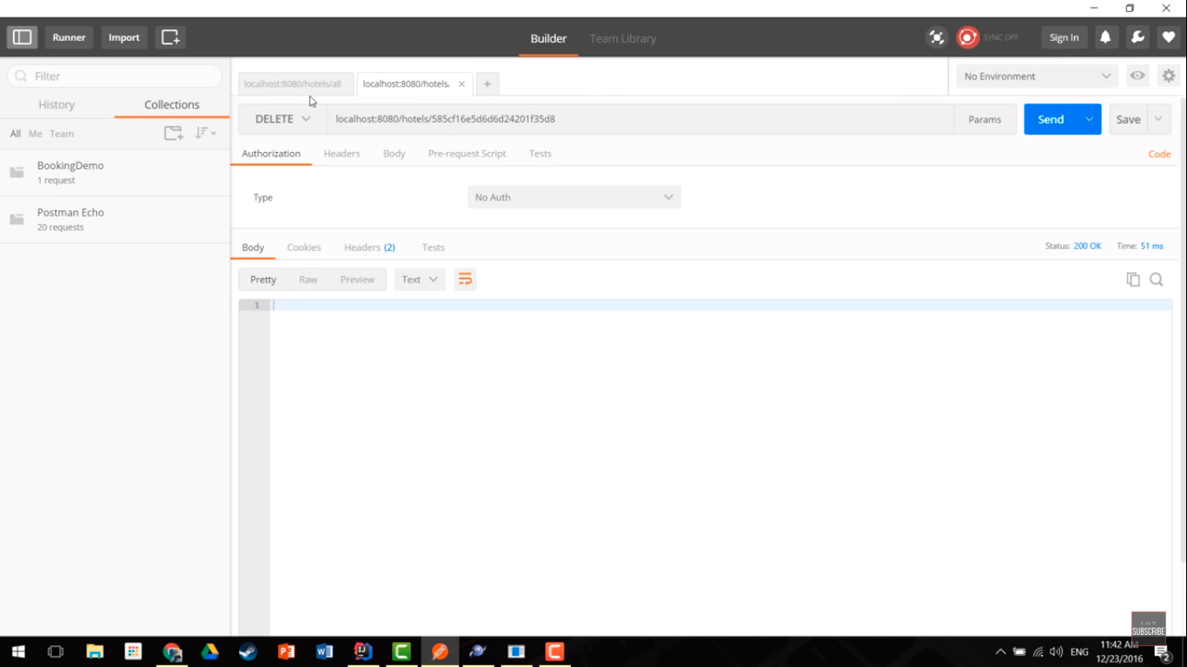

No Sofitel

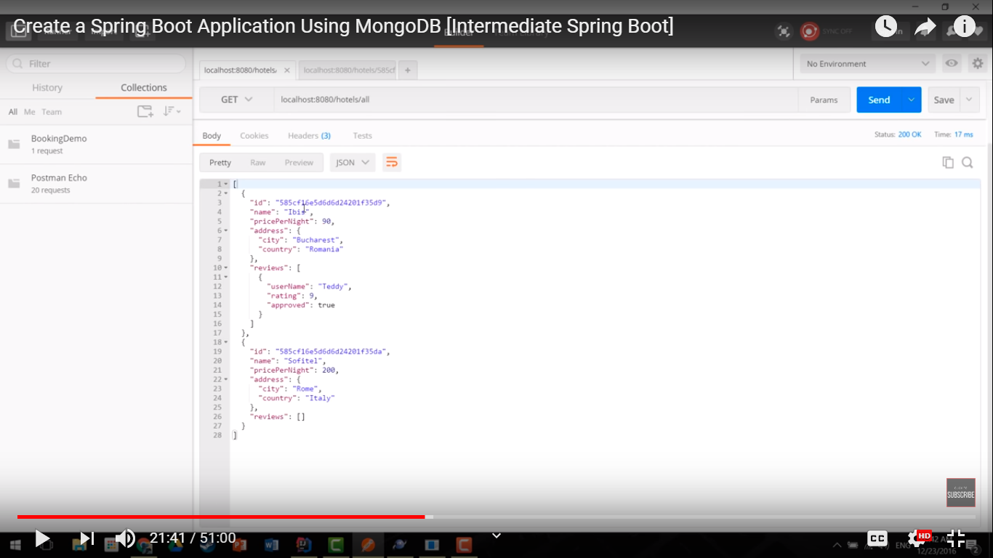

Insert a Hotel in the collection

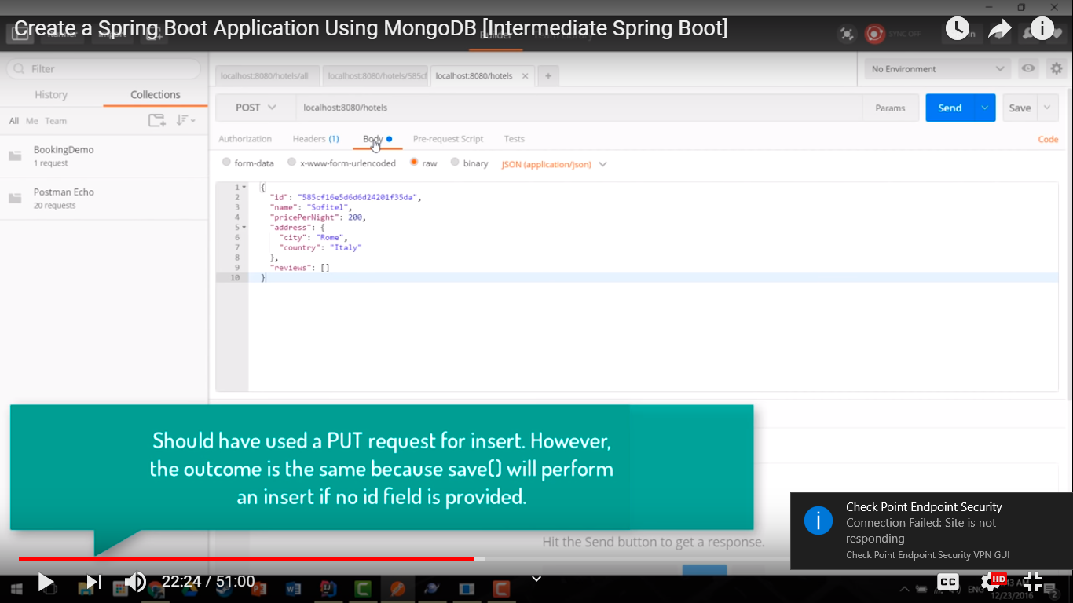

{

"id" : "3",

"name" : "Marriot",

"pricePerNight" : 140,

"address" : {

"city" : "Paris",

"country" : "France"

},

"reviews" : [

{

"userName" : "a1",

"rating" : 8,

"approved" : true

},

{

"userName" : "a2",

"rating" : 6,

"approved" : false

}

]

}

For Insert, delete the id in Request Body as it will be automatically generated.

{

"name" : "Marriot",

"pricePerNight" : 140,

"address" : {

"city" : "Paris",

"country" : "France"

},

"reviews" : [

{

"userName" : "a1",

"rating" : 8,

"approved" : true

},

{

"userName" : "a2",

"rating" : 6,

"approved" : false

}

]

}

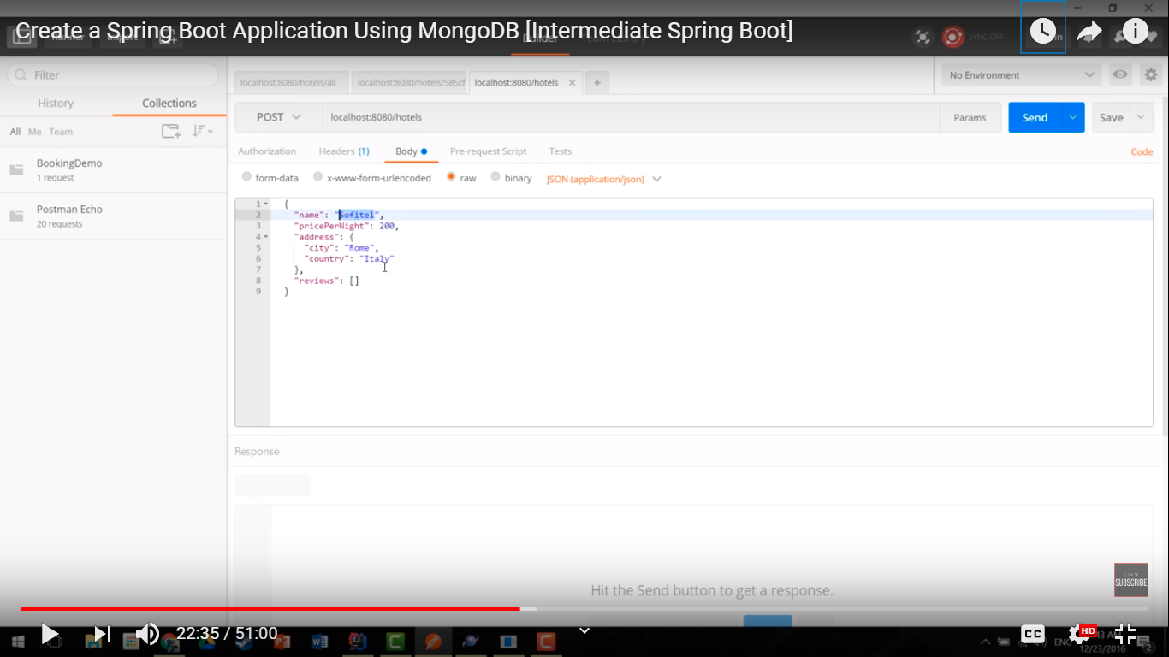

Insert another one

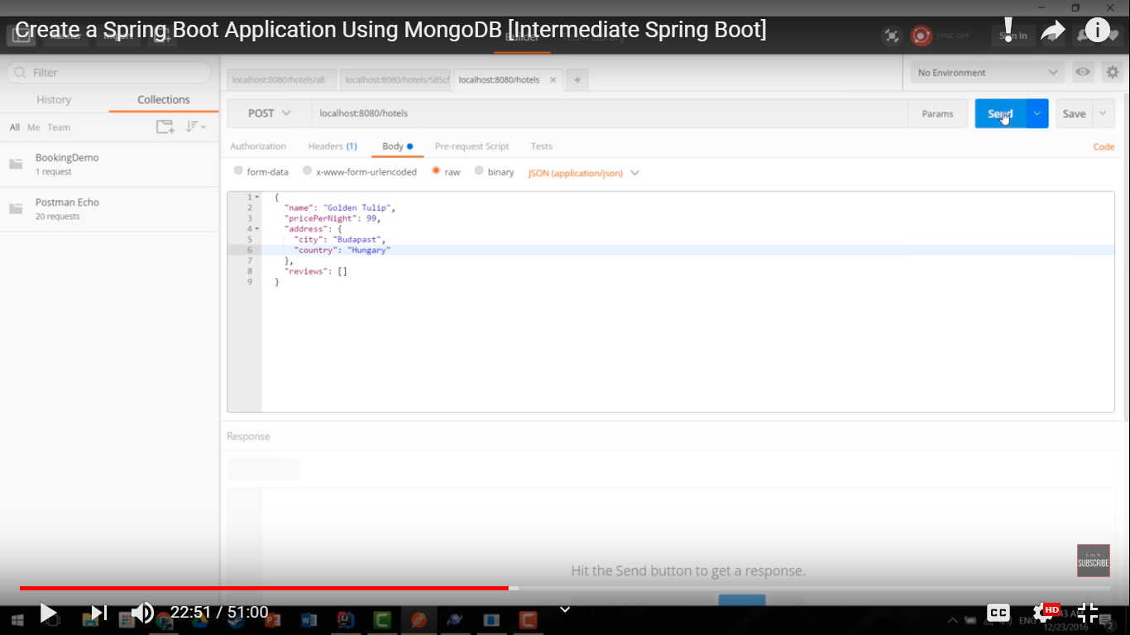

Update “Sofitel” from 200 Euros per night to 100 Euros per night

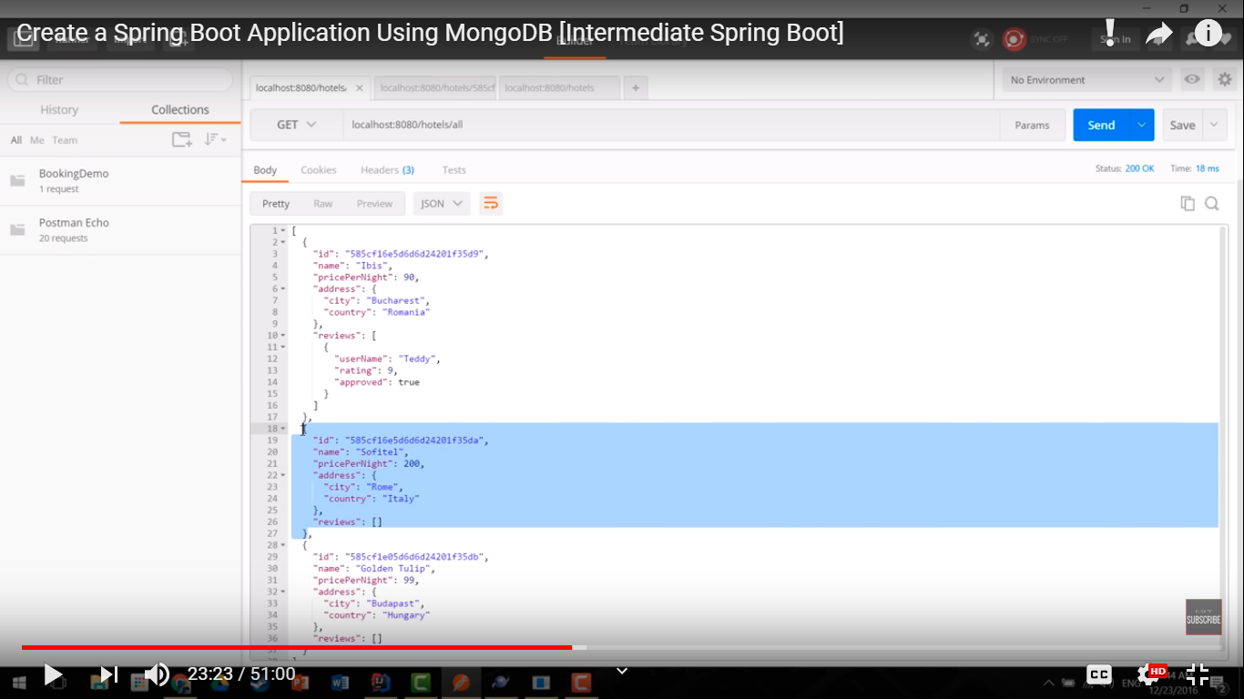

We have to pass the id now because we have to update an entity

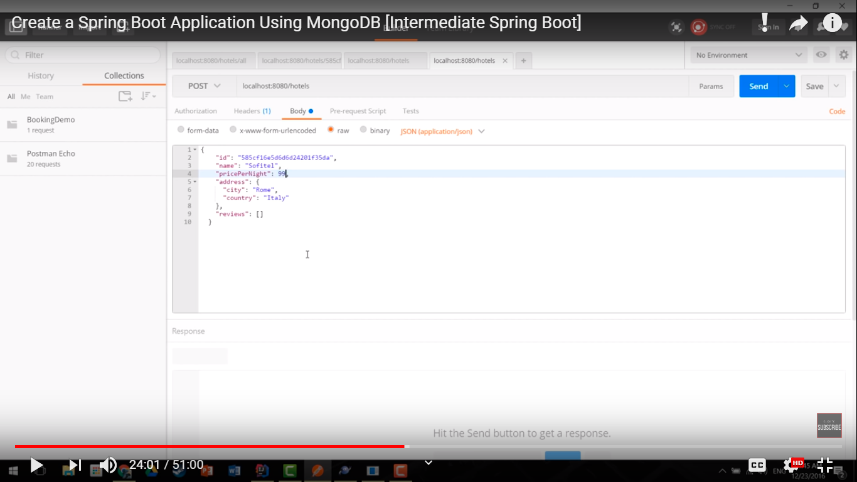

localhost:8080/update

{

"id": "3",

"name": "Marriot",

"pricePerNight": 1440,

"address": {

"city": "Paris",

"country": "France"

},

"reviews": [

{

"userName": "a1",

"rating": 8,

"approved": true

},

{

"userName": "a2",

"rating": 6,

"approved": false

}

]

}

Now hit the getAll api, we can see the change

localhost:8080/all

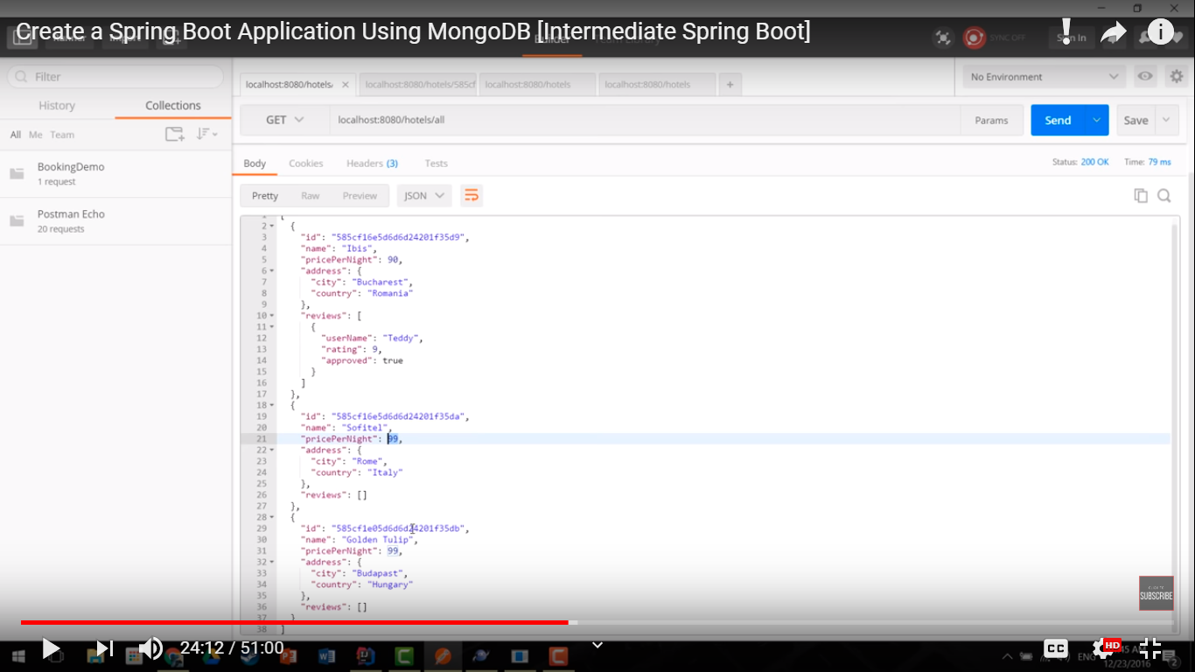

Implement most basic filter findById()

Modify Repository interface

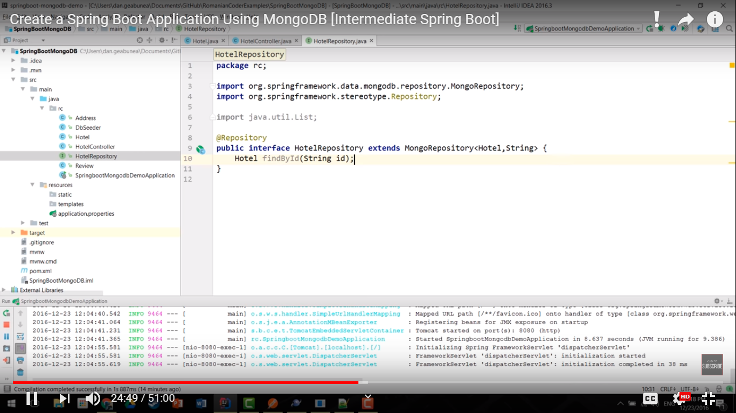

package com.soumyadeep.microservices.repoisitory;

import java.util.List;

import org.springframework.data.mongodb.repository.MongoRepository;

import org.springframework.stereotype.Repository;

import com.soumyadeep.microservices.model.Hotel;

@Repository

public interface HotelRepository extends MongoRepository<Hotel,String>{

public Hotel findById(String id);

}

In controller

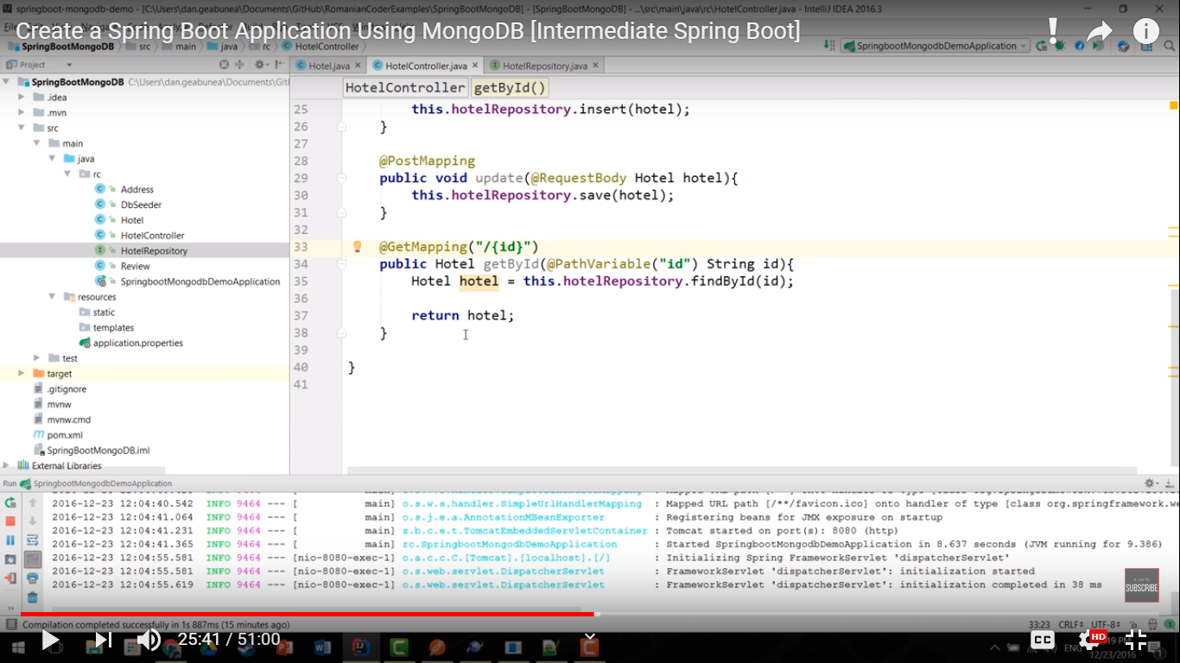

**package** com.soumyadeep.microservices.controller;

**import** java.util.List;

**import** org.springframework.beans.factory.annotation.Autowired;

**import** org.springframework.web.bind.annotation.GetMapping;

**import** org.springframework.web.bind.annotation.PathVariable;

**import** org.springframework.web.bind.annotation.RequestBody;

**import** org.springframework.web.bind.annotation.RequestMapping;

**import** org.springframework.web.bind.annotation.RequestMethod;

**import** org.springframework.web.bind.annotation.RestController;

**import** com.soumyadeep.microservices.model.Hotel;

**import** com.soumyadeep.microservices.repoisitory.HotelRepository;

@RestController

**public** **class** HotelController {

@Autowired

**private** HotelRepository hotelRepository;

@RequestMapping(value="/all")

**public** List<Hotel> findAll(){

**return** hotelRepository.findAll();

}

@RequestMapping(value="/insert", method=RequestMethod.***POST***)

**public** **void** insert(@RequestBody Hotel hotel){

hotelRepository.save(hotel);

}

@RequestMapping(value="/update", method=RequestMethod.***PUT***)

**public** **void** update(@RequestBody Hotel hotel){

hotelRepository.save(hotel);

}

@RequestMapping(value="/{id}", method=RequestMethod.***DELETE***)

**public** **void** delete(@PathVariable(name="id") String id){

hotelRepository.delete(id);

}

@RequestMapping(value="/{id}", method=RequestMethod.***GET***)

**public** Hotel getById(@PathVariable(name="id") String id){

**return** hotelRepository.findById(id);

}

}

Find Hotel where pricePerNight is less than 100 Euros

In Repository interface, don’t make spelling mistake

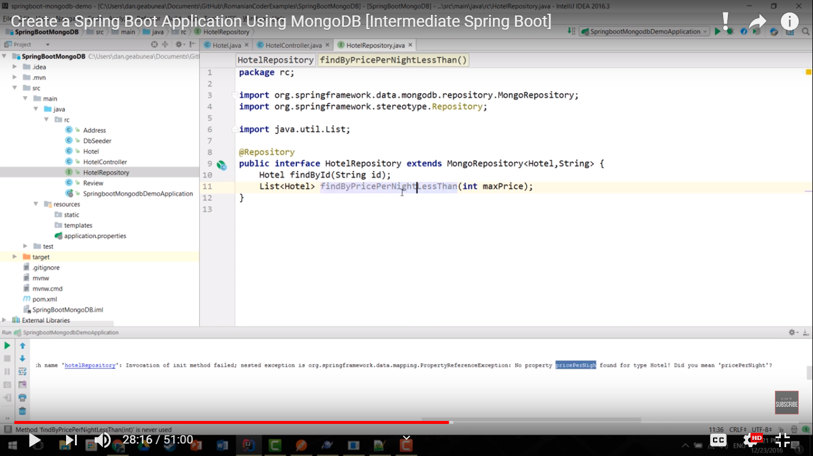

package com.soumyadeep.microservices.repoisitory;

import java.util.List;

import org.springframework.data.mongodb.repository.MongoRepository;

import org.springframework.stereotype.Repository;

import com.soumyadeep.microservices.model.Hotel;

@Repository

public interface HotelRepository extends MongoRepository<Hotel,String>{

public Hotel findById(String id);

public List<Hotel> findByPricePerNightLessThan(int maxPrice);

}

In controller

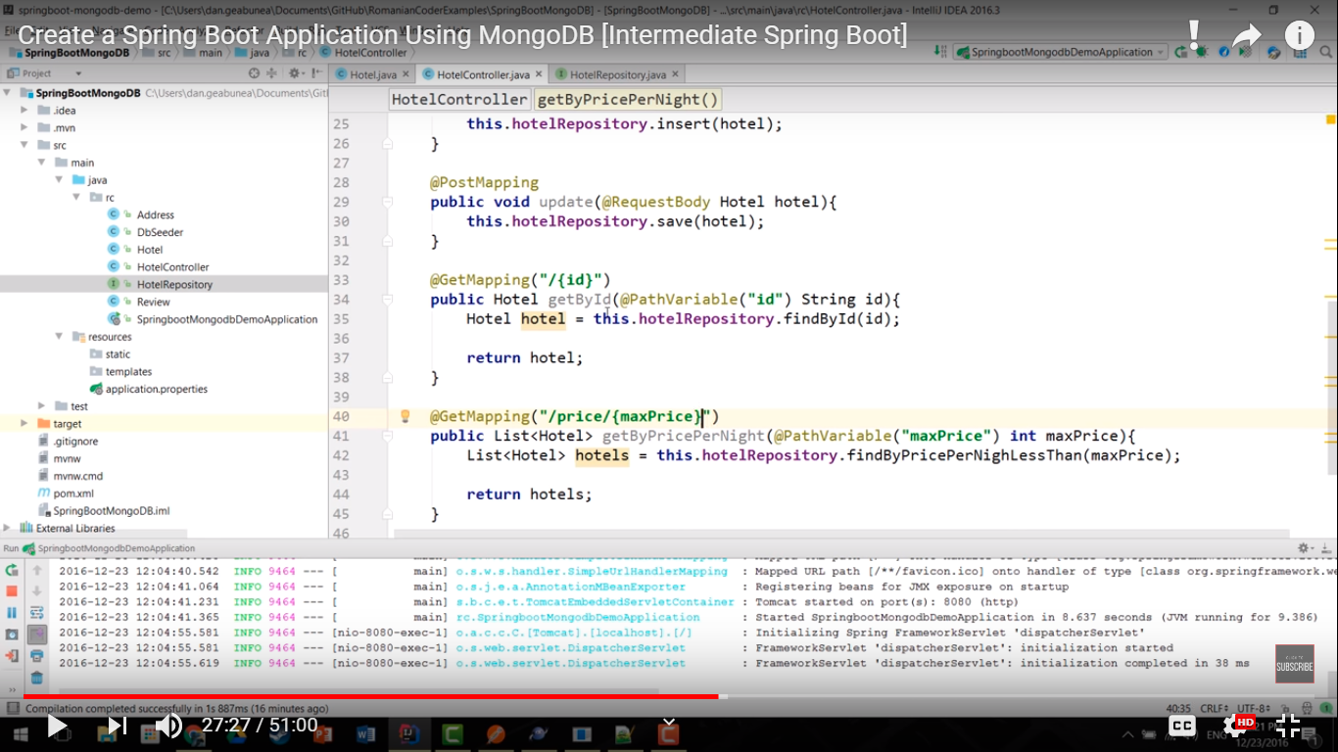

**package** com.soumyadeep.microservices.controller;

**import** java.util.List;

**import** org.springframework.beans.factory.annotation.Autowired;

**import** org.springframework.web.bind.annotation.GetMapping;

**import** org.springframework.web.bind.annotation.PathVariable;

**import** org.springframework.web.bind.annotation.RequestBody;

**import** org.springframework.web.bind.annotation.RequestMapping;

**import** org.springframework.web.bind.annotation.RequestMethod;

**import** org.springframework.web.bind.annotation.RestController;

**import** com.soumyadeep.microservices.model.Hotel;

**import** com.soumyadeep.microservices.repoisitory.HotelRepository;

@RestController

**public** **class** HotelController {

@Autowired

**private** HotelRepository hotelRepository;

@RequestMapping(value="/all")

**public** List<Hotel> findAll(){

**return** hotelRepository.findAll();

}

@RequestMapping(value="/insert", method=RequestMethod.***POST***)

**public** **void** insert(@RequestBody Hotel hotel){

hotelRepository.save(hotel);

}

@RequestMapping(value="/update", method=RequestMethod.***PUT***)

**public** **void** update(@RequestBody Hotel hotel){

hotelRepository.save(hotel);

}

@RequestMapping(value="/{id}", method=RequestMethod.***DELETE***)

**public** **void** delete(@PathVariable(name="id") String id){

hotelRepository.delete(id);

}

@RequestMapping(value="/{id}", method=RequestMethod.***GET***)

**public** Hotel getById(@PathVariable(name="id") String id){

**return** hotelRepository.findById(id);

}

@GetMapping(value="/price/{maxPrice}")

**public** List<Hotel> getByPricePerNight(@PathVariable(name="maxPrice") **int** maxPrice){

**return** hotelRepository.findByPricePerNightLessThan(maxPrice);

}

}

Start the application

Find by id

localhost:8080/3

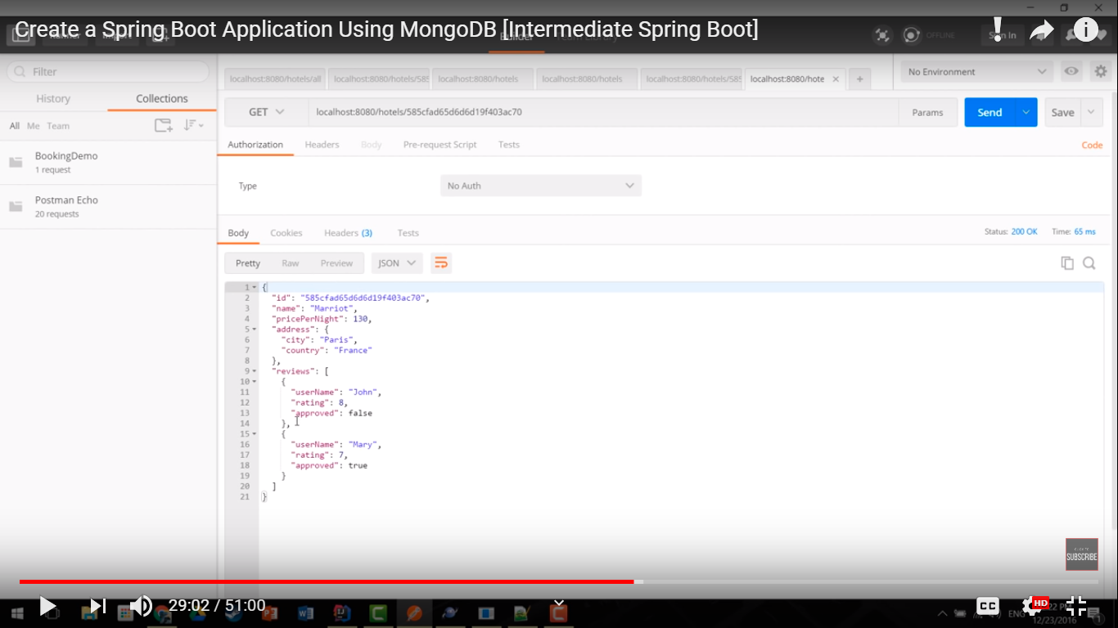

Filtering with price per night

localhost:8080/price/160

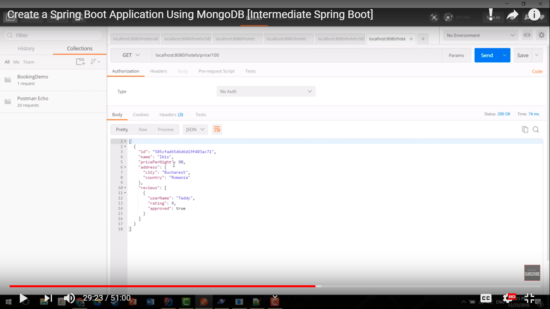

Till now we have filtered with root property of the Hotel object

What if we want to filter by city in address, then we cannot use the naming convention but we can do so by @Query annotation

In Repository

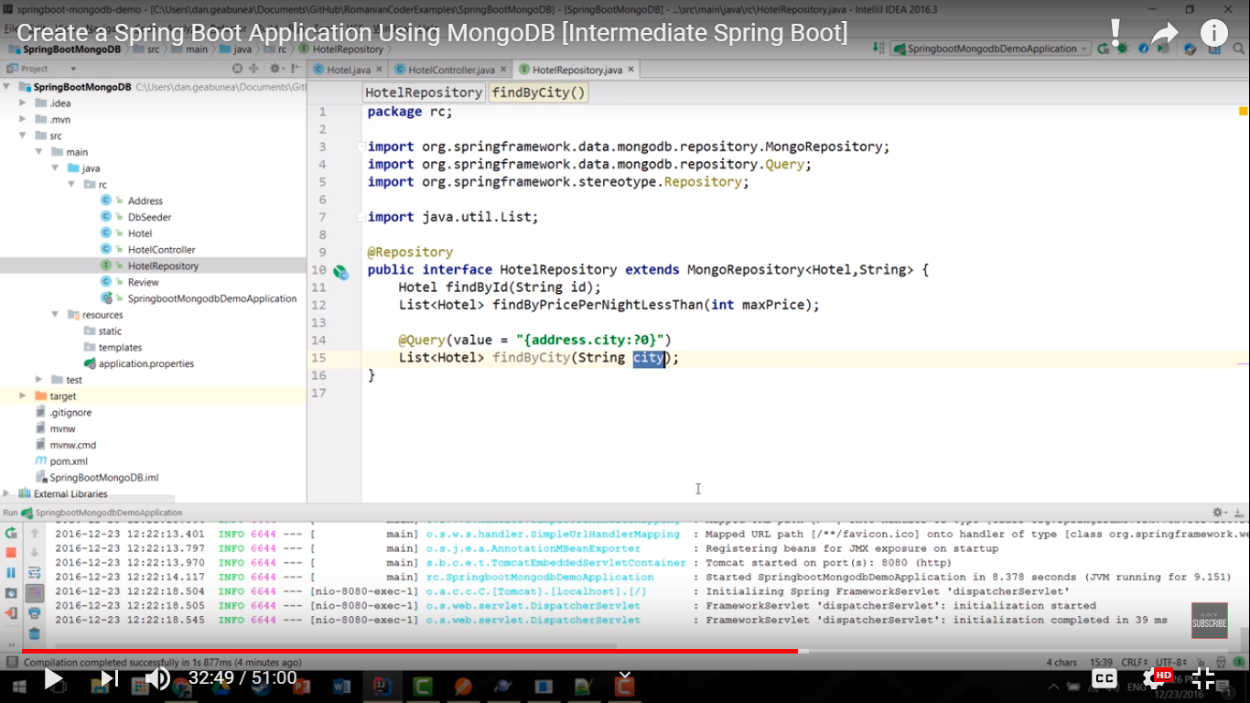

package com.soumyadeep.microservices.repoisitory;

import java.util.List;

import org.springframework.data.mongodb.repository.MongoRepository;

import org.springframework.data.mongodb.repository.Query;

import org.springframework.stereotype.Repository;

import com.soumyadeep.microservices.model.Hotel;

@Repository

public interface HotelRepository extends MongoRepository<Hotel,String>{

public Hotel findById(String id);

public List<Hotel> findByPricePerNightLessThan(int maxPrice);

@Query(value="{address.city:?0}")

public List<Hotel> findByCity(String city);

}

Try the actual filter query in Robomongo

db.getCollection('Hotels').find({"address.country":"France"})

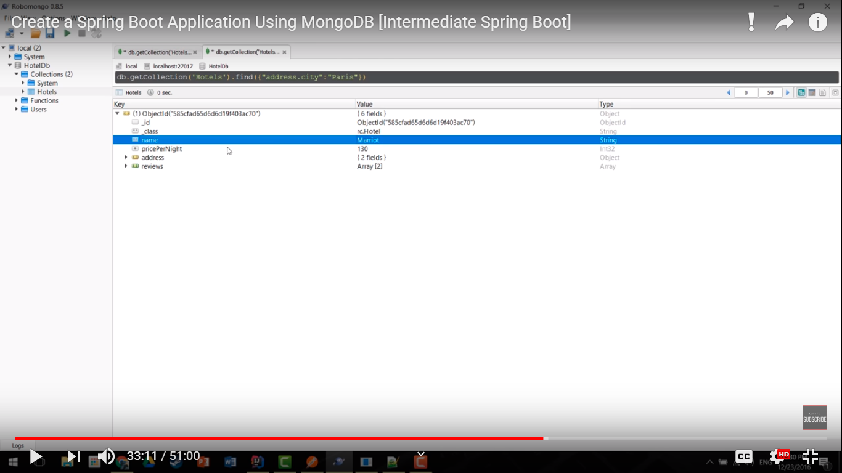

In controller

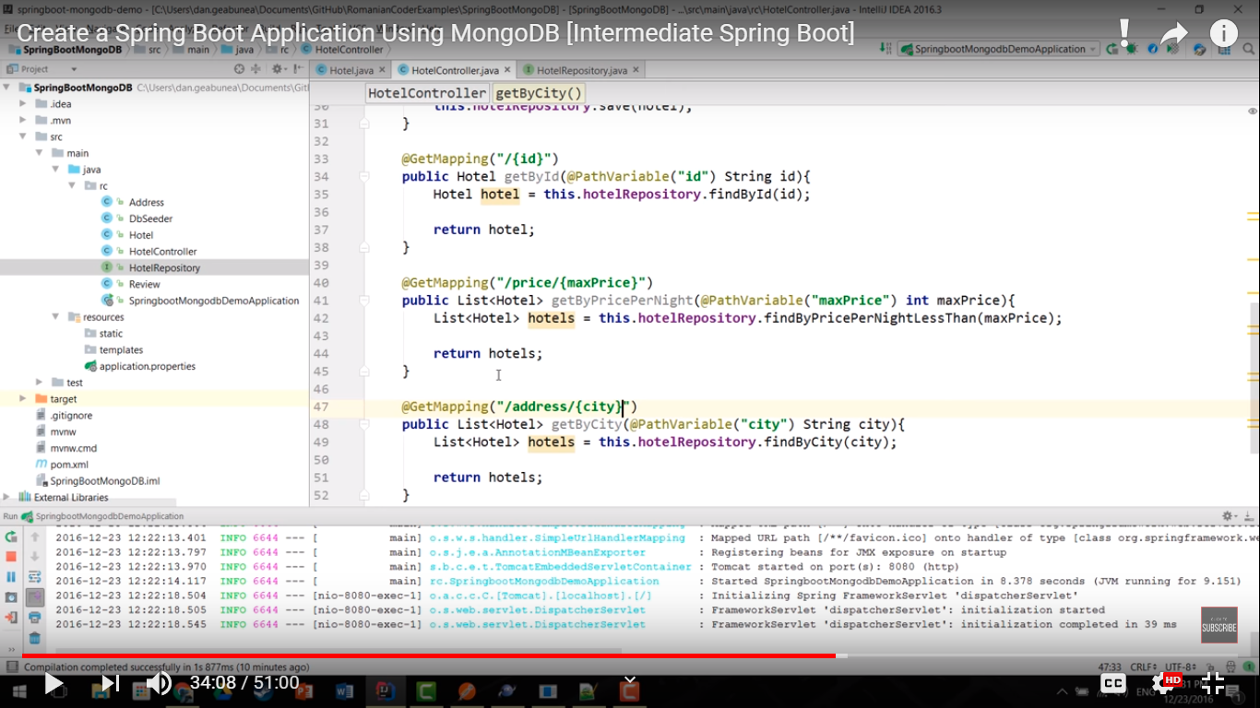

**package** com.soumyadeep.microservices.controller;

**import** java.util.List;

**import** org.springframework.beans.factory.annotation.Autowired;

**import** org.springframework.web.bind.annotation.GetMapping;

**import** org.springframework.web.bind.annotation.PathVariable;

**import** org.springframework.web.bind.annotation.RequestBody;

**import** org.springframework.web.bind.annotation.RequestMapping;

**import** org.springframework.web.bind.annotation.RequestMethod;

**import** org.springframework.web.bind.annotation.RestController;

**import** com.soumyadeep.microservices.model.Hotel;

**import** com.soumyadeep.microservices.repoisitory.HotelRepository;

@RestController

**public** **class** HotelController {

@Autowired

**private** HotelRepository hotelRepository;

@RequestMapping(value="/all")

**public** List<Hotel> findAll(){

**return** hotelRepository.findAll();

}

@RequestMapping(value="/insert", method=RequestMethod.***POST***)

**public** **void** insert(@RequestBody Hotel hotel){

hotelRepository.save(hotel);

}

@RequestMapping(value="/update", method=RequestMethod.***PUT***)

**public** **void** update(@RequestBody Hotel hotel){

hotelRepository.save(hotel);

}

@RequestMapping(value="/{id}", method=RequestMethod.***DELETE***)

**public** **void** delete(@PathVariable(name="id") String id){

hotelRepository.delete(id);

}

@RequestMapping(value="/{id}", method=RequestMethod.***GET***)

**public** Hotel getById(@PathVariable(name="id") String id){

**return** hotelRepository.findById(id);

}

@GetMapping(value="/price/{maxPrice}")

**public** List<Hotel> getByPricePerNight(@PathVariable(name="maxPrice") **int** maxPrice){

**return** hotelRepository.findByPricePerNightLessThan(maxPrice);

}

//db.getCollection('Hotels').find({"address.country":"France"})

//What if we want to filter by city in address, then we cannot use the naming

//convention but we can do so by @Query annotation

@GetMapping(value="/address/{city}")

**public** List<Hotel> getByCity(@PathVariable(name="city") String city){

**return** hotelRepository.findByCity(city);

}

}

Start the Application

localhost:8080/address/Paris

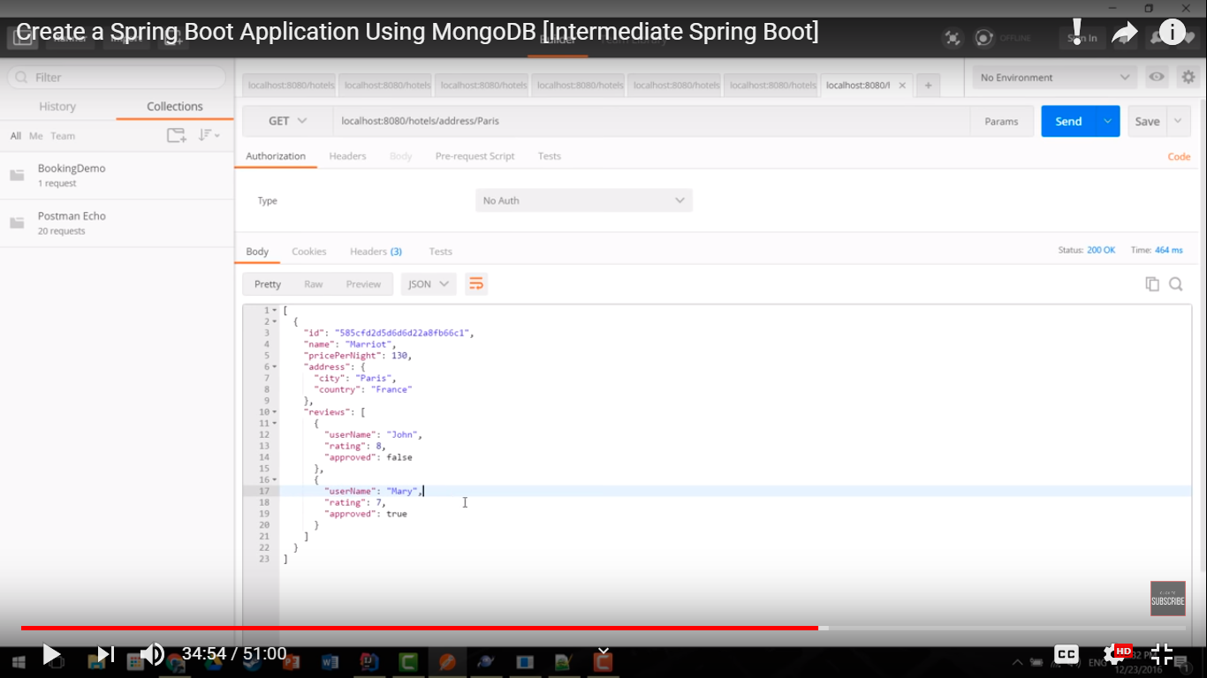

We need to find a way to Query Mongo database in a typed manner.

Mongo Query DSL enables us to type Mongo Query DSL in a typed manner.

In pom.xml add dependency and plugin

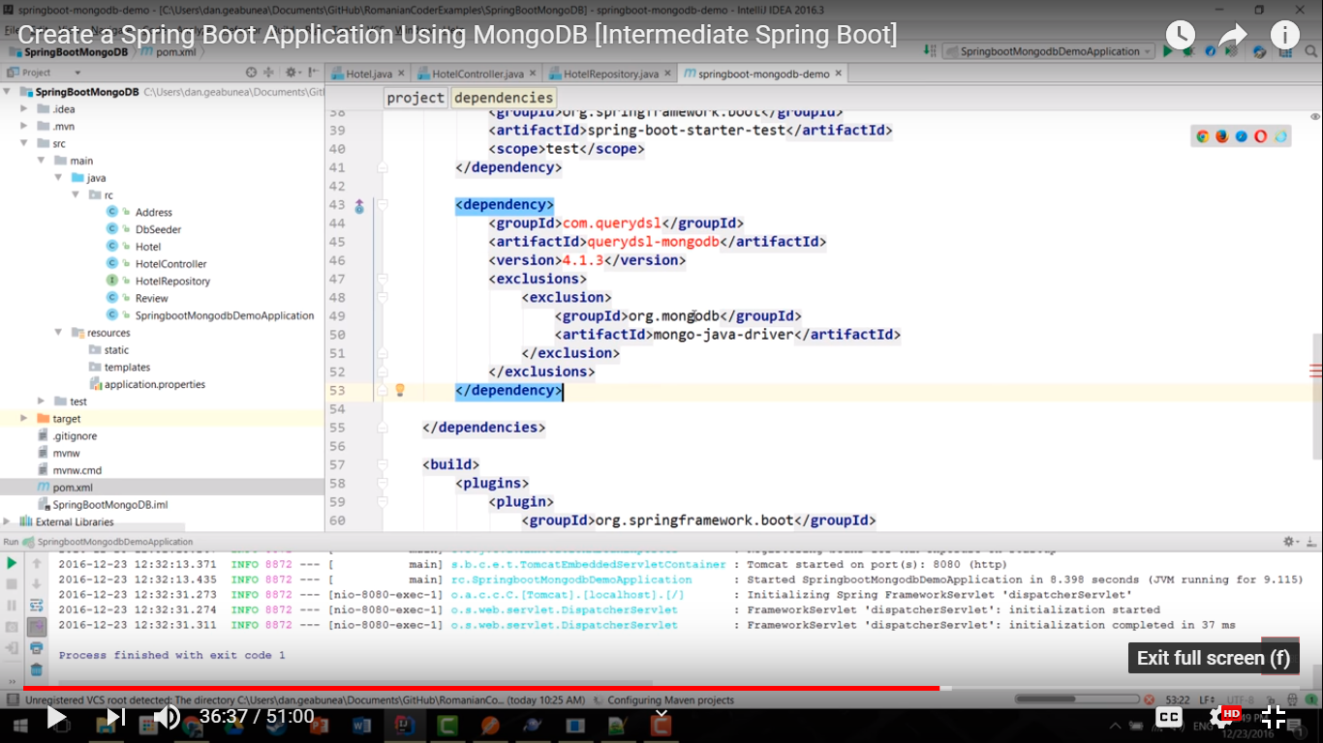

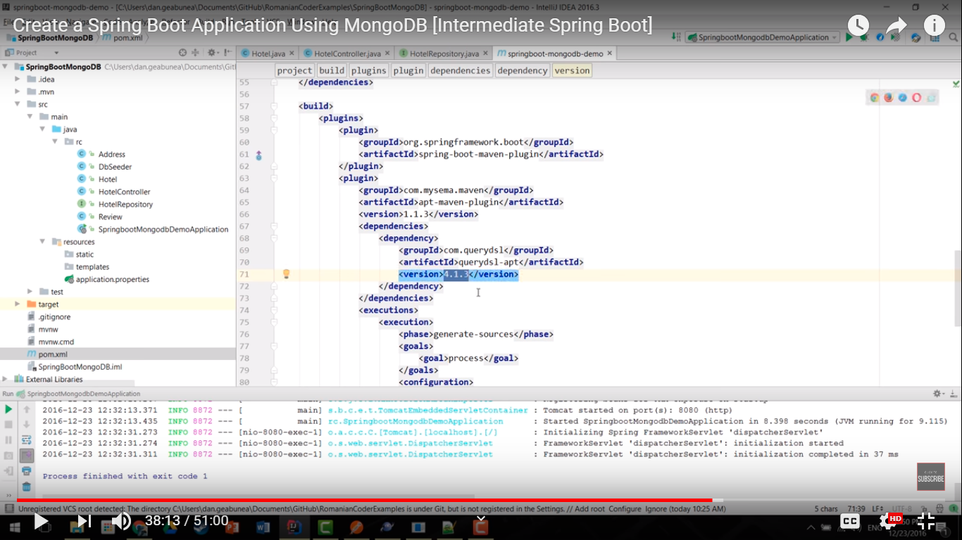

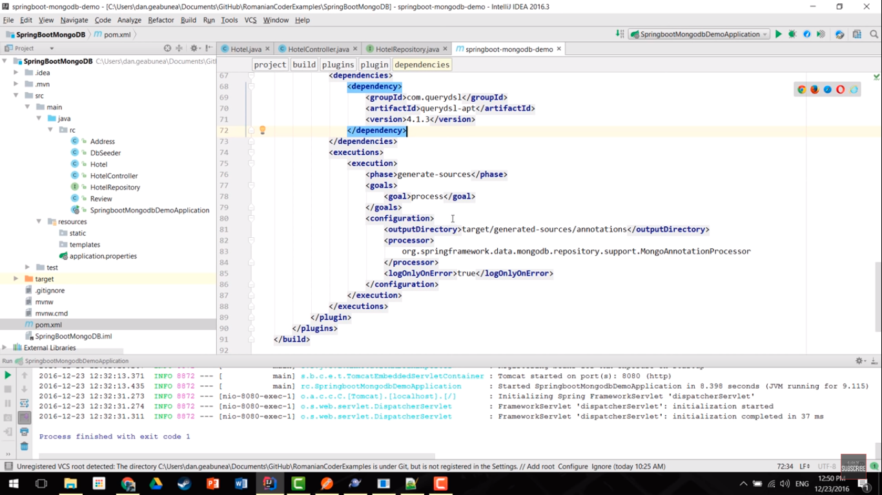

In Repository

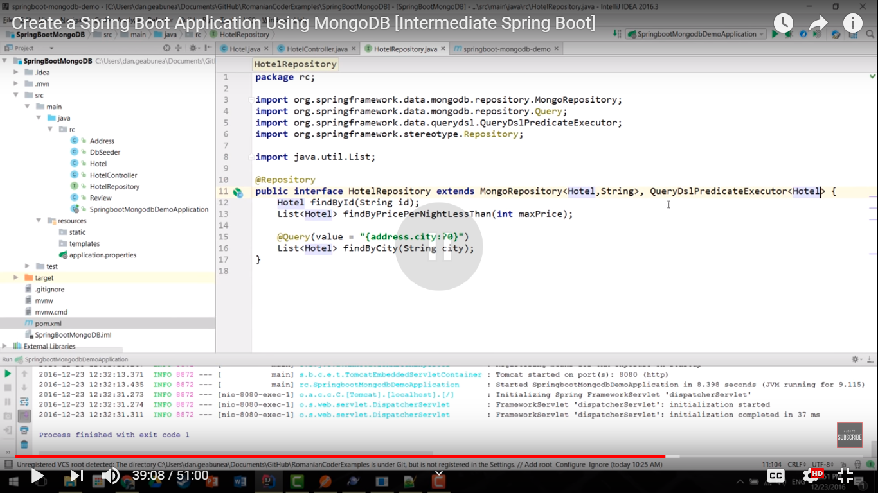

**package** com.soumyadeep.microservices.repoisitory;

**import** java.util.List;

**import** org.springframework.data.mongodb.repository.MongoRepository;

**import** org.springframework.data.mongodb.repository.Query;

**import** org.springframework.data.querydsl.QueryDslPredicateExecutor;

**import** org.springframework.stereotype.Repository;

**import** com.soumyadeep.microservices.model.Hotel;

@Repository

**public** **interface** HotelRepository **extends** MongoRepository<Hotel,String>, QueryDslPredicateExecutor<Hotel>{

**public** Hotel findById(String id);

**public** List<Hotel> findByPricePerNightLessThan(**int** maxPrice);

@Query(value="{address.city:?0}")

**public** List<Hotel> findByCity(String city);

}

Generate Maven Project 🡪 package

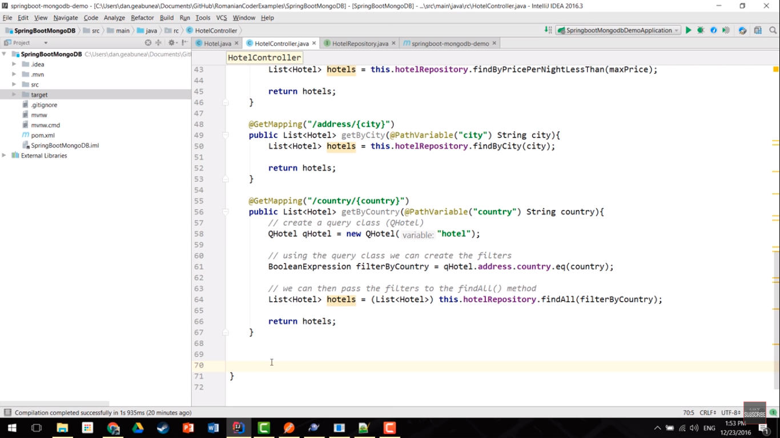

@GetMapping(value = "/country/{country}")

**public** List<Hotel> getByCountry(@PathVariable(name = "country") String country) {

QHotel qHotel = **new** QHotel("hotel");

BooleanExpression filterByCountry = qHotel.address.country.eq(country);

List<Hotel> hotels = (List<Hotel>) hotelRepository.findAll(filterByCountry);

**return** hotels;

}

More complex query

Filter by 2 condition

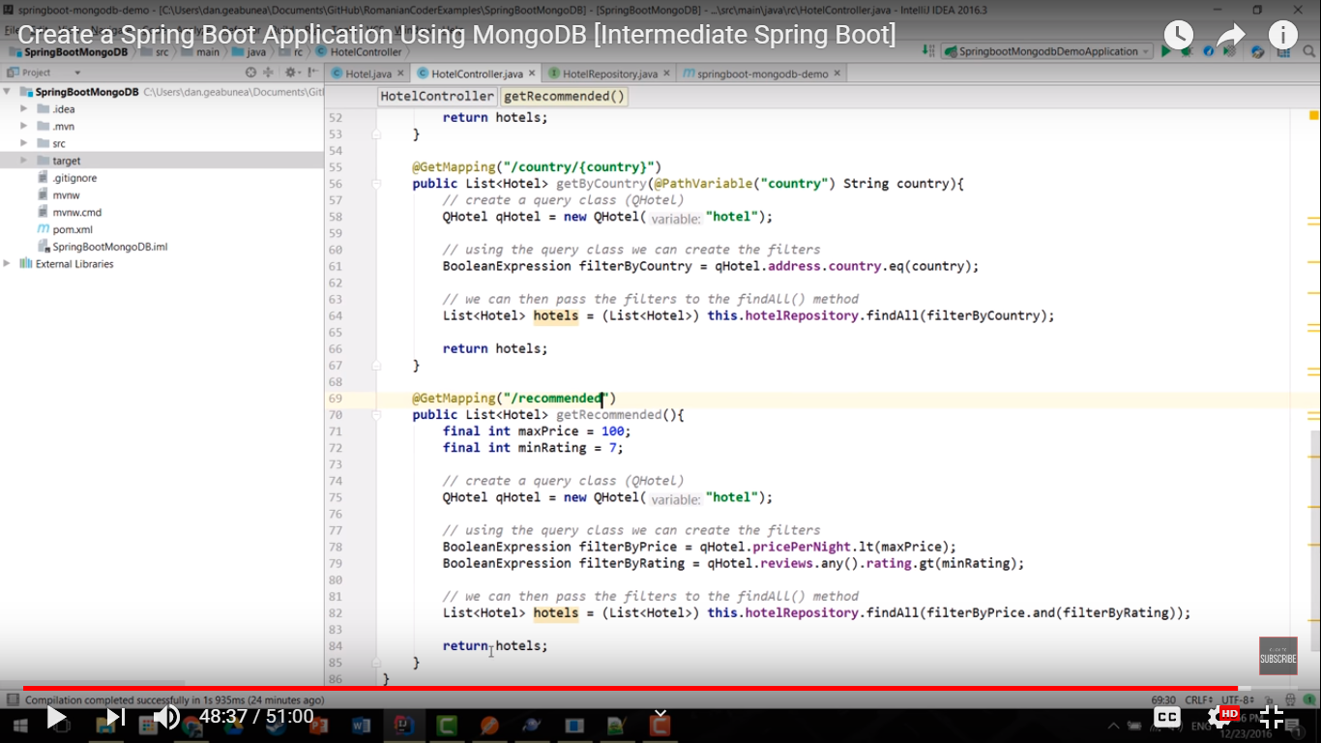

**package** com.soumyadeep.microservices.controller;

**import** java.util.List;

**import** org.springframework.beans.factory.annotation.Autowired;

**import** org.springframework.web.bind.annotation.GetMapping;

**import** org.springframework.web.bind.annotation.PathVariable;

**import** org.springframework.web.bind.annotation.RequestBody;

**import** org.springframework.web.bind.annotation.RequestMapping;

**import** org.springframework.web.bind.annotation.RequestMethod;

**import** org.springframework.web.bind.annotation.RestController;

**import** com.querydsl.core.types.dsl.BooleanExpression;

**import** com.soumyadeep.microservices.model.Hotel;

**import** com.soumyadeep.microservices.model.QHotel;

**import** com.soumyadeep.microservices.repoisitory.HotelRepository;

@RestController

**public** **class** HotelController {

@Autowired

**private** HotelRepository hotelRepository;

@RequestMapping(value = "/all")

**public** List<Hotel> findAll() {

**return** hotelRepository.findAll();

}

@RequestMapping(value = "/insert", method = RequestMethod.***POST***)

**public** **void** insert(@RequestBody Hotel hotel) {

hotelRepository.save(hotel);

}

@RequestMapping(value = "/update", method = RequestMethod.***PUT***)

**public** **void** update(@RequestBody Hotel hotel) {

hotelRepository.save(hotel);

}

@RequestMapping(value = "/{id}", method = RequestMethod.***DELETE***)

**public** **void** delete(@PathVariable(name = "id") String id) {

hotelRepository.delete(id);

}

@RequestMapping(value = "/{id}", method = RequestMethod.***GET***)

**public** Hotel getById(@PathVariable(name = "id") String id) {

**return** hotelRepository.findById(id);

}

@GetMapping(value = "/price/{maxPrice}")

**public** List<Hotel> getByPricePerNight(@PathVariable(name = "maxPrice") **int** maxPrice) {

**return** hotelRepository.findByPricePerNightLessThan(maxPrice);

}

// db.getCollection('Hotels').find({"address.country":"France"})

// What if we want to filter by city in address, then we cannot use the naming

// convention but we can do so by @Query annotation

@GetMapping(value = "/address/{city}")

**public** List<Hotel> getByCity(@PathVariable(name = "city") String city) {

**return** hotelRepository.findByCity(city);

}

@GetMapping(value = "/country/{country}")

**public** List<Hotel> getByCountry(@PathVariable(name = "country") String country) {

QHotel qHotel = **new** QHotel("hotel");

BooleanExpression filterByCountry = qHotel.address.country.eq(country);

List<Hotel> hotels = (List<Hotel>) hotelRepository.findAll(filterByCountry);

**return** hotels;

}

@GetMapping(value = "/recommended")

**public** List<Hotel> getByRecommendation() {

**final** **int** maxPrice = 160;

**final** **int** minRating = 2;

QHotel qHotel = **new** QHotel("hotel");

BooleanExpression filterByPrice = qHotel.pricePerNight.eq(maxPrice);

BooleanExpression filterByRating = qHotel.reviews.any().rating.eq(minRating);

List<Hotel> hotels = (List<Hotel>) hotelRepository.findAll(filterByPrice.and(filterByPrice));

**return** hotels;

}

}

Start the application

Find by country with Query

localhost:8080/country/France

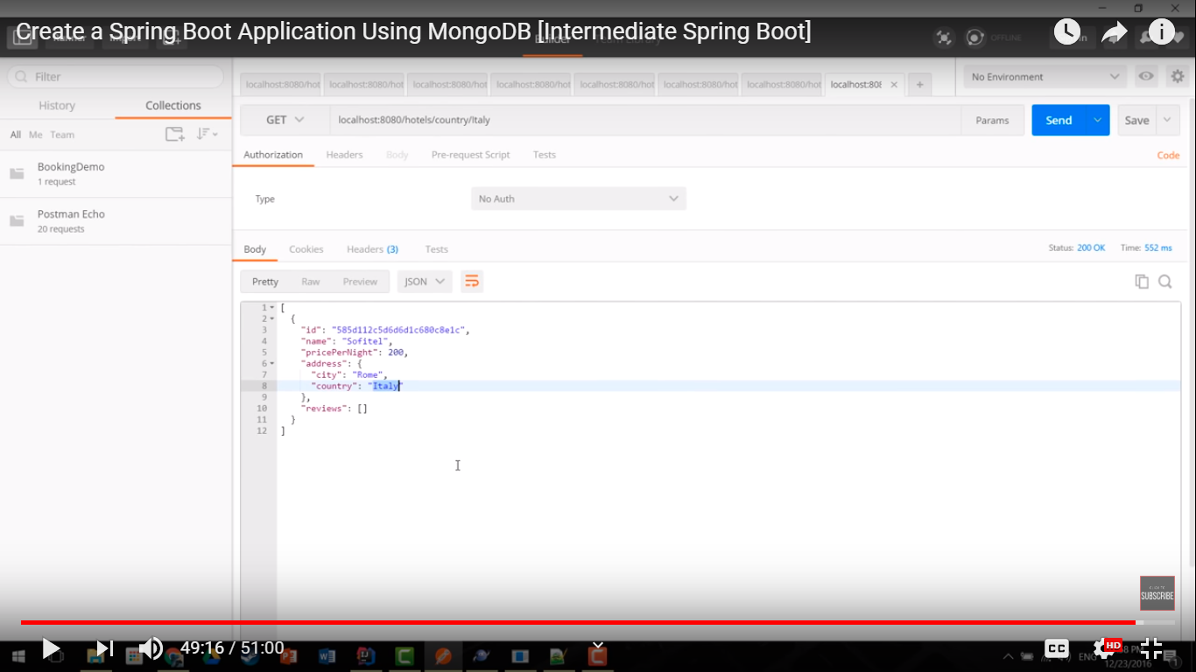

Filter by 2 condition

localhost:8080/recommended

